Joshua McKeen  
CS 3733 – Individual Project Part 1

Use Case: Quit Application  
Participating Actor: Initiated by user  
Entry Condition: None  
Exit Criteria: PuzzleApp terminates  
Flow of Events:  
1. user requests to quit the application  
2. PuzzleApp Terminates

Use Case: Select Tile  
Participating Actor: Initiated by user  
Entry Condition: None  
Exit Criteria: Tile is selected  
Flow of Events:  
1. user requests to select a tile  
2. PuzzleApp selects the tile and updates display to indicate the player’s selection

Use Case: Move Tile  
Participating Actor: Initiated by user  
Entry Condition: One tile has been selected  
Exit Criteria: Tile has been merged with tile in direction it has moved in  
Flow of Events:  
1. user requests to move tile in a certain valid direction  
2. PuzzleApp moves the tile, merging it and computing the new number for the tile in that direction, updating the display to show the result

Use Case: Puzzle Solved  
Participating Actor: Initiated by user  
Entry Condition: One tile has been selected  
Exit Criteria: the puzzle is solved with a single number in the middle of the board, congratulations is displayed  
Flow of events:  
1. user requests to move tile in a certain valid direction  
2. PuzzleApp moves the tile, merging it and computing the new number for the tile in that direction, updates the display and congratulates the user for solving the puzzle

Use Case: User Loses  
Participating Actor: Initiated by user  
Entry Condition: One tile has been selected  
Exit Criteria: The puzzle has reached a state where it’s impossible to solve and the user is notified  
Flow of events:  
1. user requests to move tile in a certain valid direction  
2. PuzzleApp moves the tile, merging it and computing the new number for the tile in that direction, updates the display and informs the user that it is impossible to solve the puzzle and they have lost.

Use Case: Reset Puzzle  
Participating Actor: Initiated by user  
Exit Criteria: Puzzle is reset to original configuration  
Flow of events:  
1. User requests to reset the puzzle  
2. PuzzleApp resets the playing board to the original configuration and updates the display

Storyboard/Mockup for in-progress game:

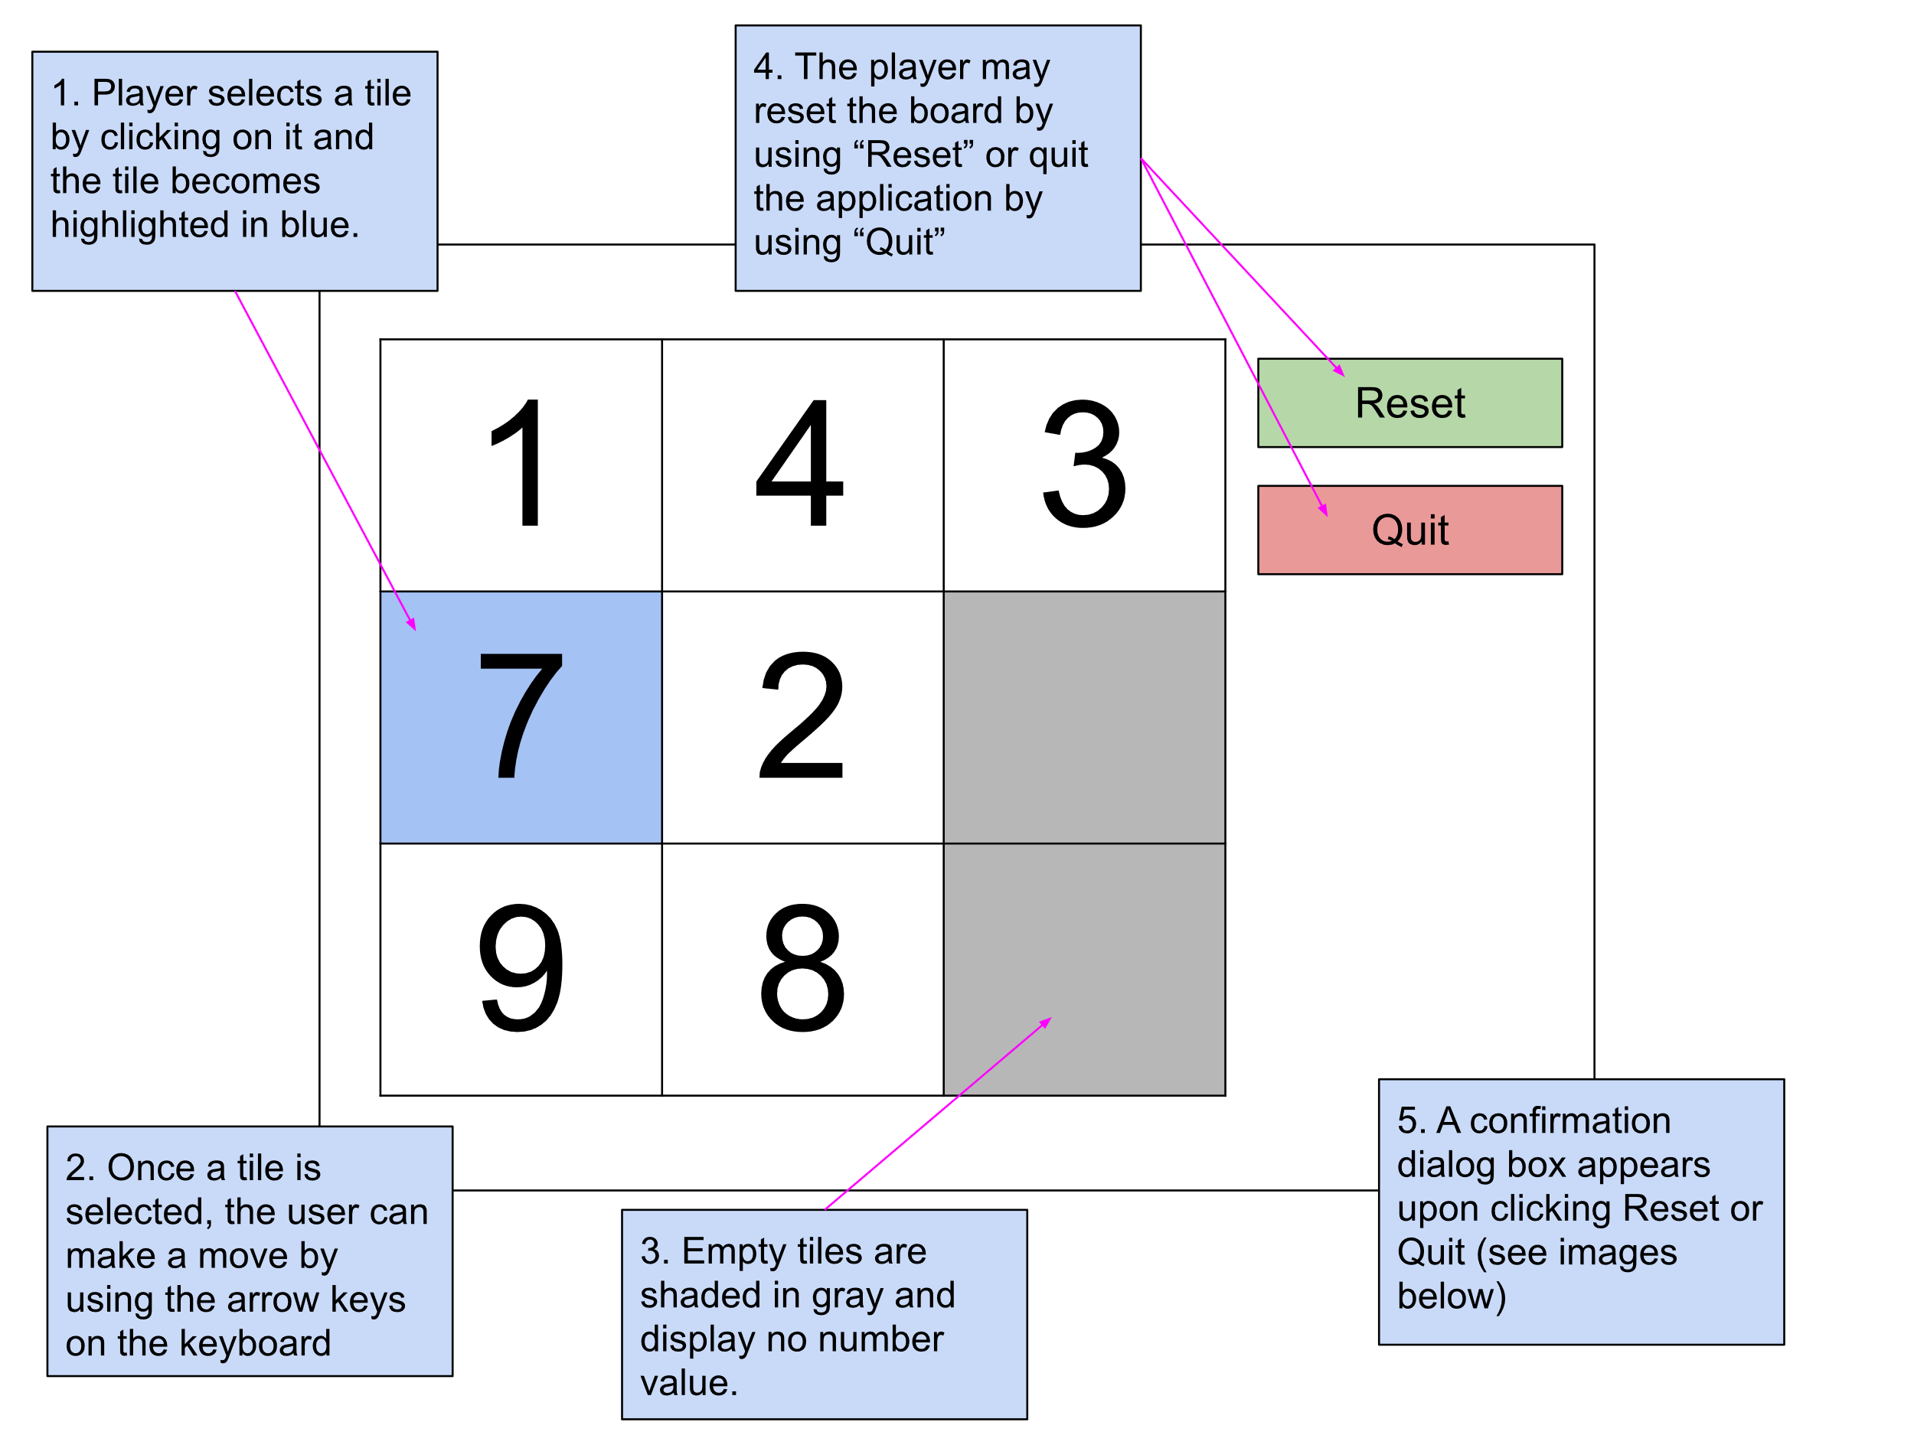

NOTE: If the user presses an arrow key for a direction that represents an invalid move the program will not make the move and the current tile will remain selected.

Confirmation dialog boxes:

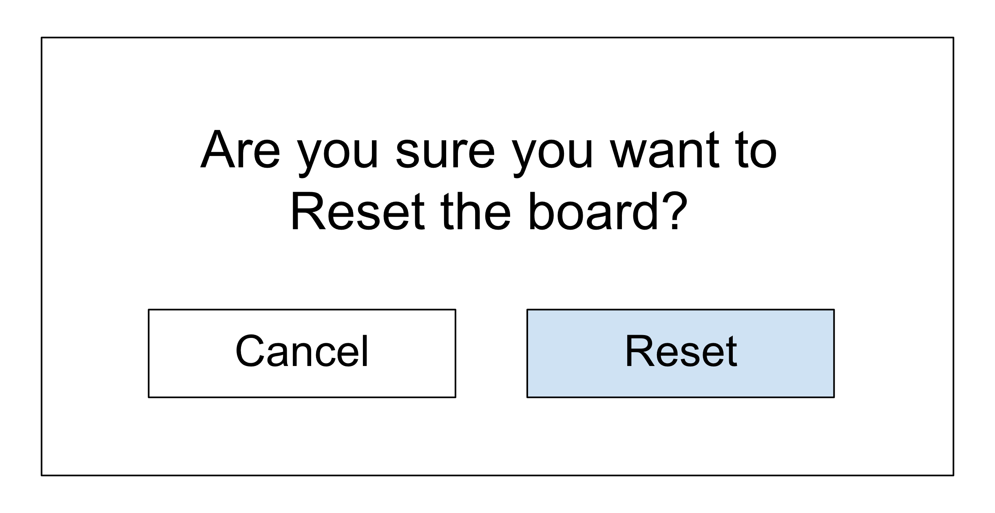 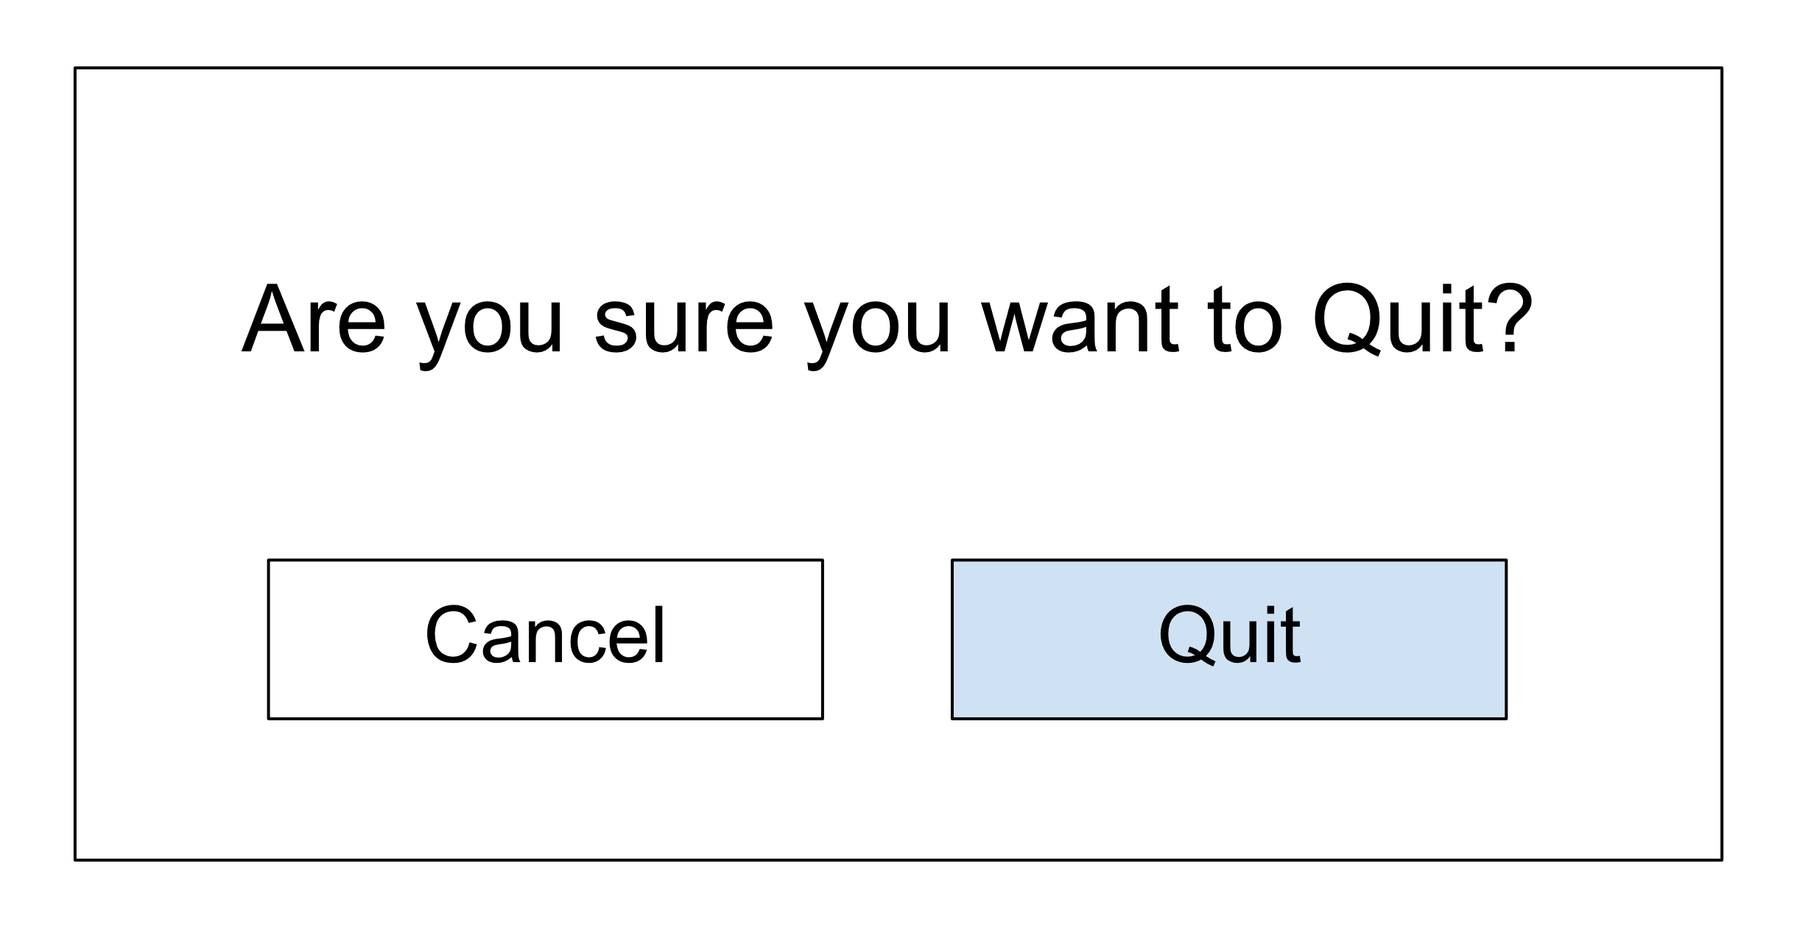

Storyboard/mockup for concluded game:  
A message is displayed at the bottom of the board indicating if the user has won or lost and prompts the user to either reset the board or quit the application.

Player cannot make any more moves:

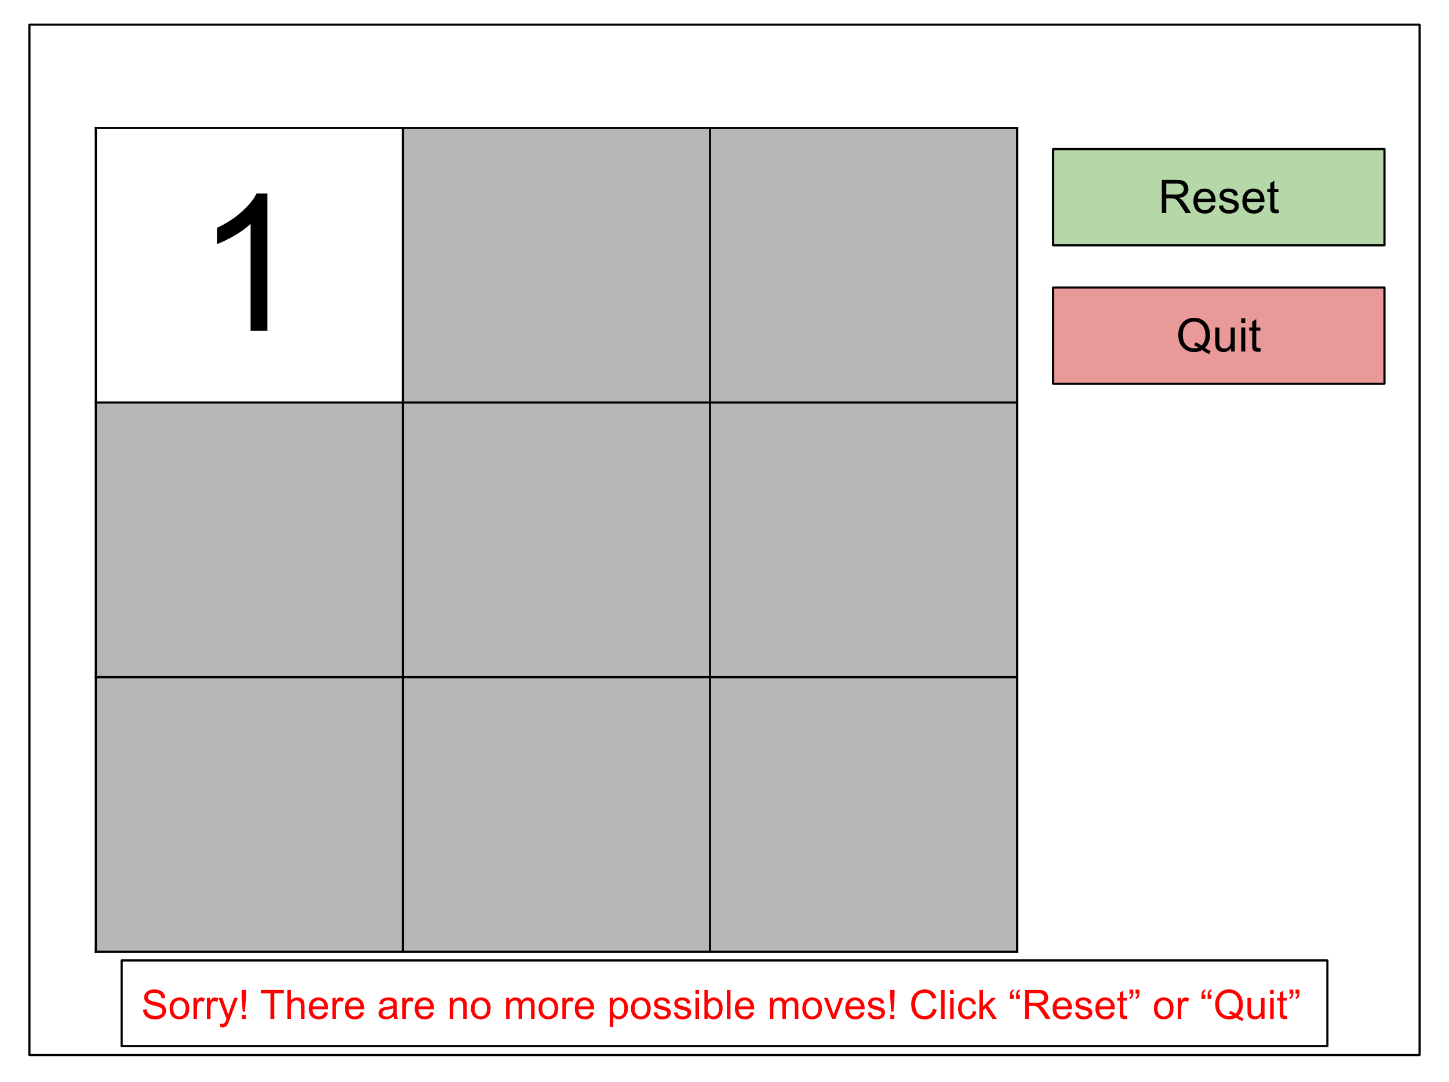

Player solves the puzzle:

